Nithin S
221IT085

IT250 Lab Assignment 10

Q.Write Lex and Yacc program for the following

1) which accepts strings that start and end with p or q.

Lex Code

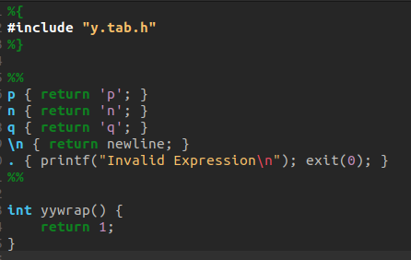

Yacc Code

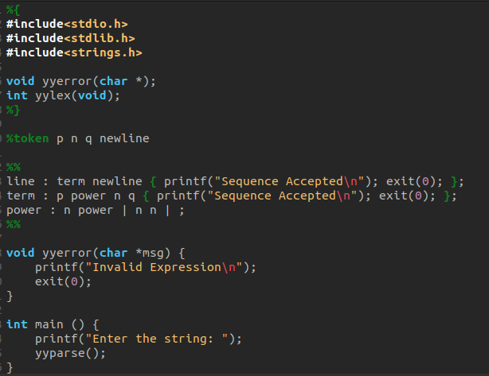

OUTPUT

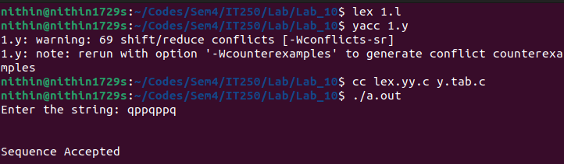

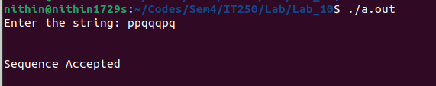

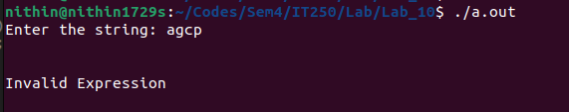

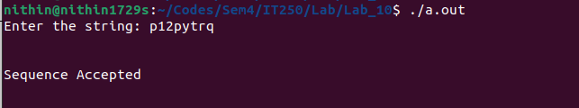
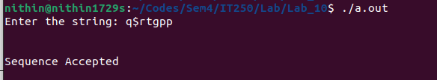

2) to recognize strings of { p^nq | n ≥ 3 }

Lex Code

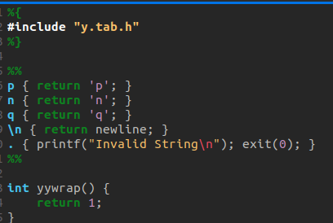

Yacc Code

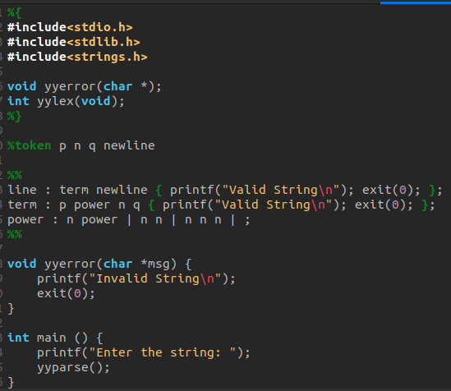

OUTPUT

